Sri Poornaprajna Evening College, Udupi

Department of Post Graduate Studies in Commerce

Activity Report 2018-19 to 2022-23

Activity Report 2020-21:

1.PG department of commerce and women empowerment cell jointly organized a webinar on “common gynecological issues among women’s and remedies ‘on 17th October, 2020. Dr Vidyashree G Poojari , Associate Professor , Department of Obstetrics and Gynecology , Kasturba Medical College , Manipal, MAHE was the resource person for the webinar

2. A career preparatory talk on “Campus to Corporate” was held on September 11th, 2020, with Mr Jaikishan Bhat M was the resource person.
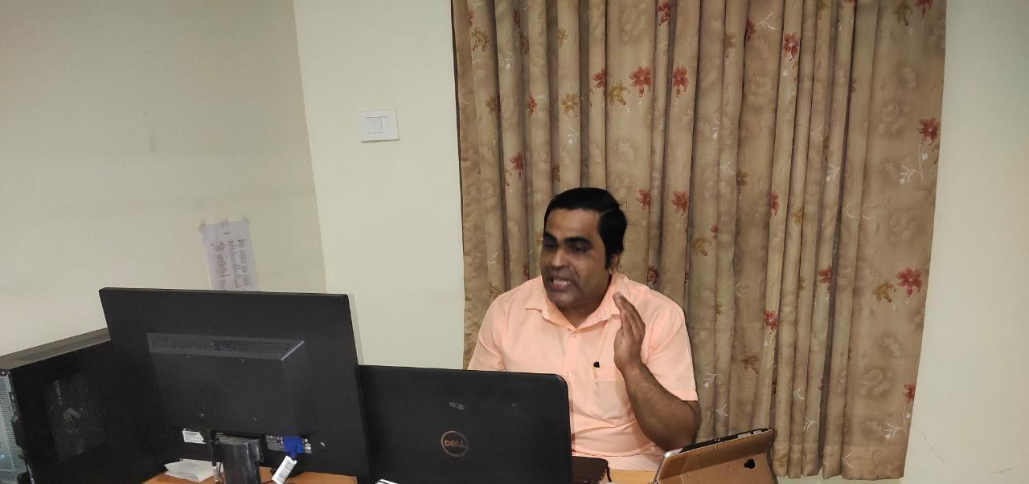
3.Festival of Lights “Deepavali “was celebrated on 12th November 2020.

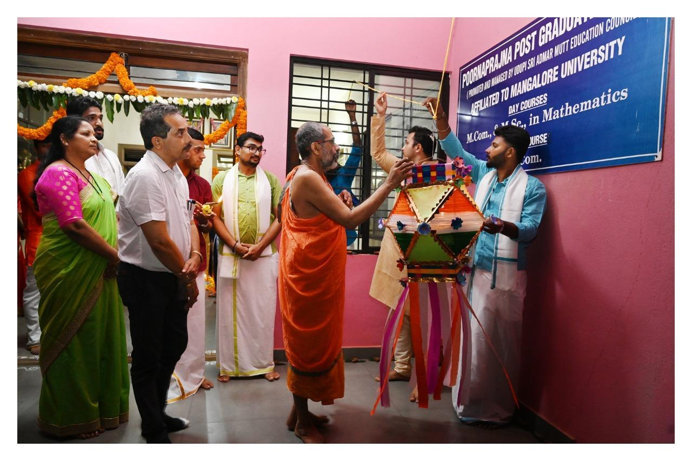
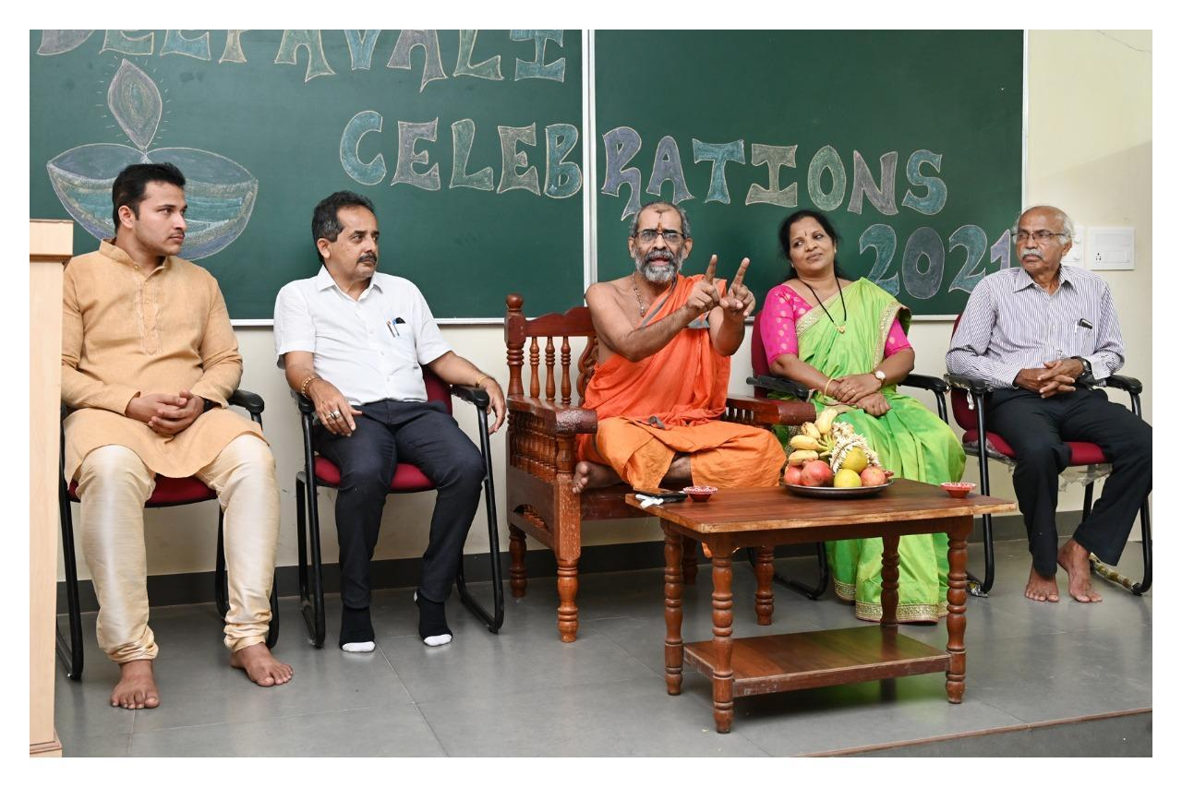
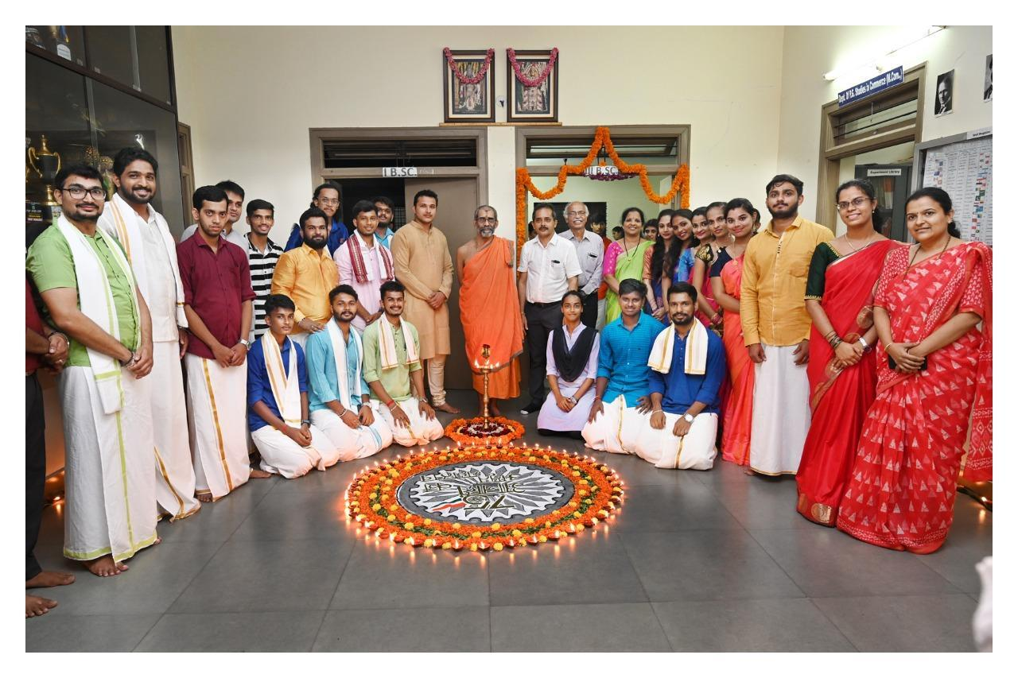
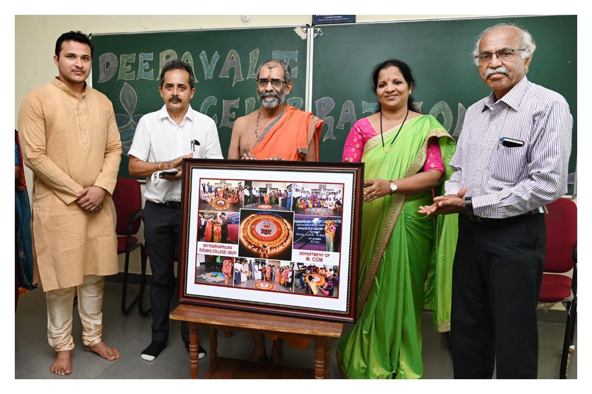

4. Mrs Sri Devi Baliga , Head of the department of commerce , Poornaprajna Pre-University College , Udupi , has taken a session on “ Mcom as a stepping stone to teaching Career “ on18th December , 2020
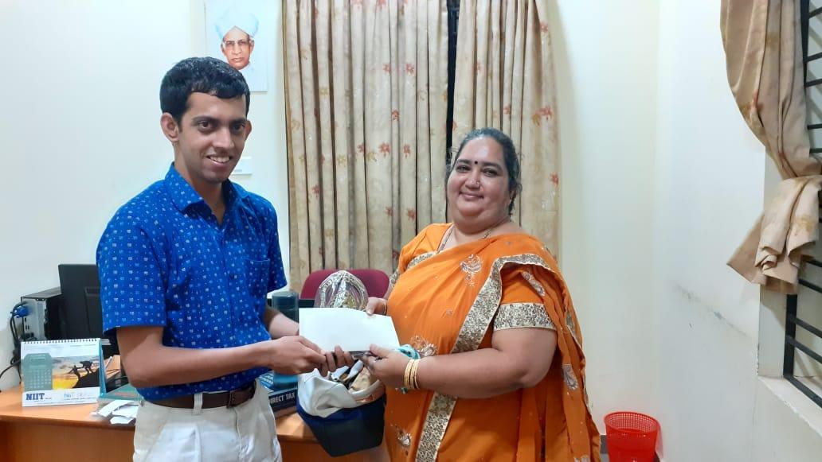

5.An intra-campus quiz competition Prajna 2021 was organized by PG Department of Commerce to the Undergraduate students of Poornaprajna College on 28th August 2021.
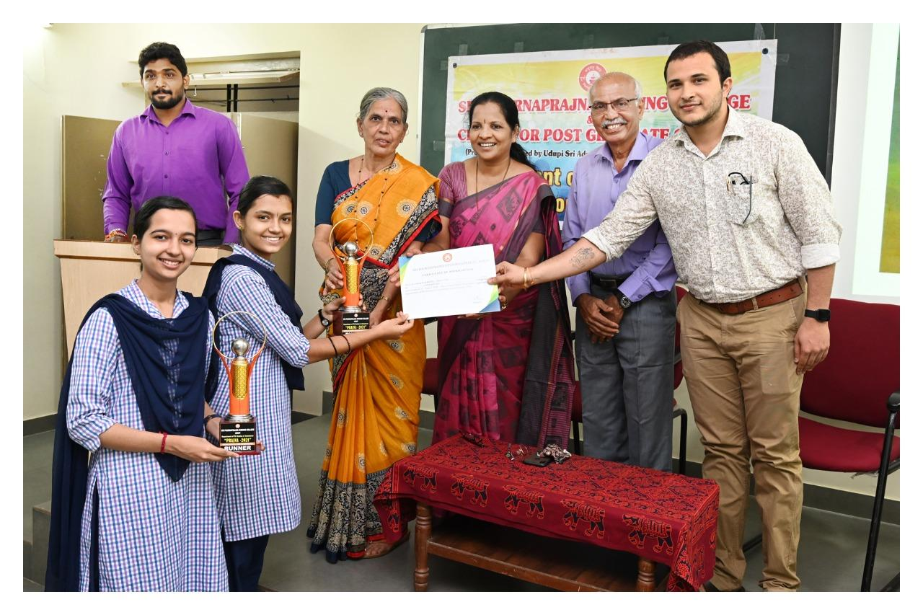
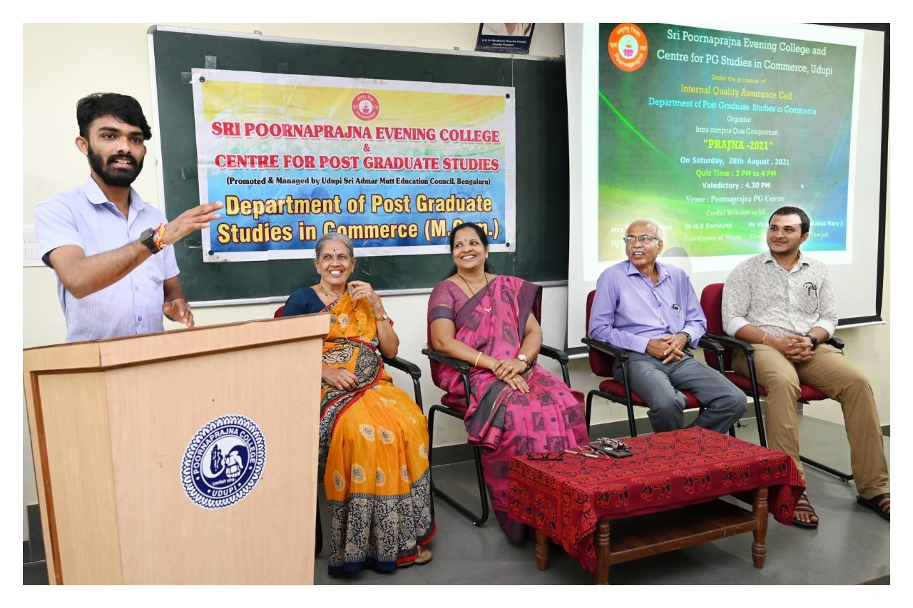

Activities Report : 2021-2022
1.Inauguration of PG Programme for the Academic Year 2021-2022 was held on 20 January 2022
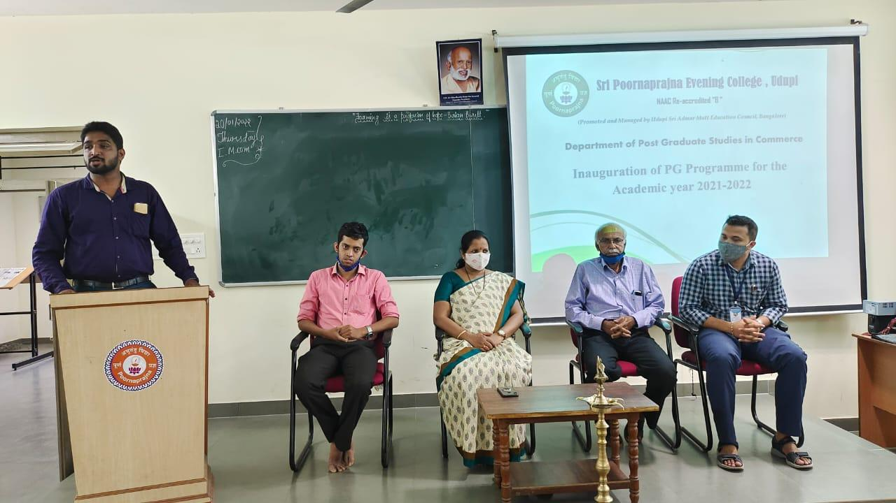

2. Brand Rangoli competition was organized on 21 /12/ 2021. The objective of the activity was to create awareness about the brand logos of different companies.

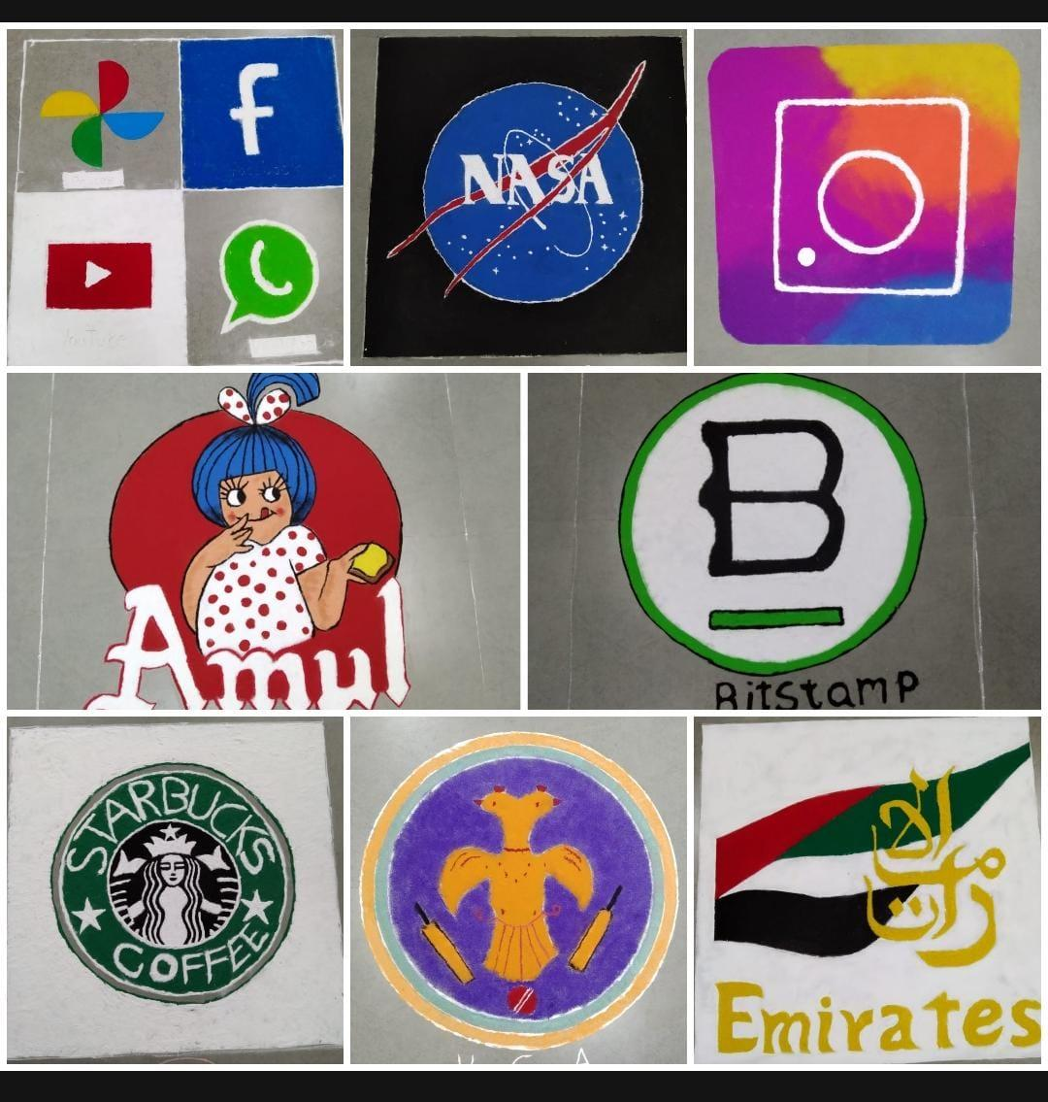

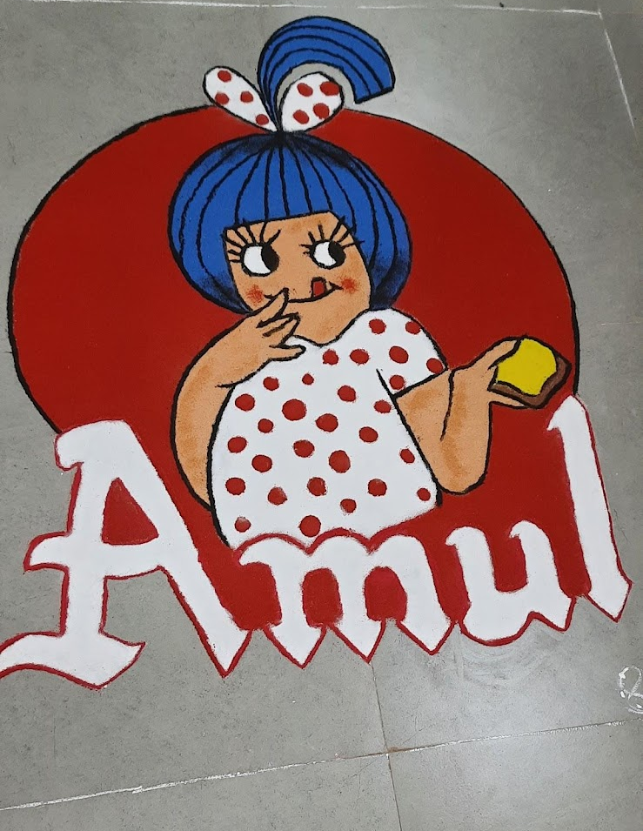

3.Commerce model making competition was conducted on 24 February 2022 for Second Mcom students with the objective to provide a learning experience .

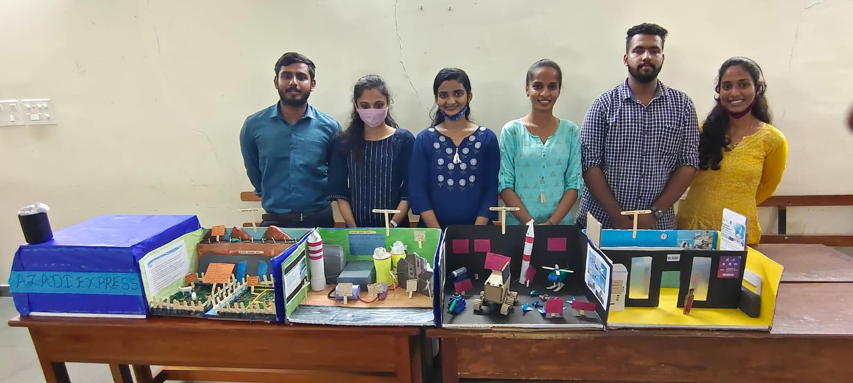

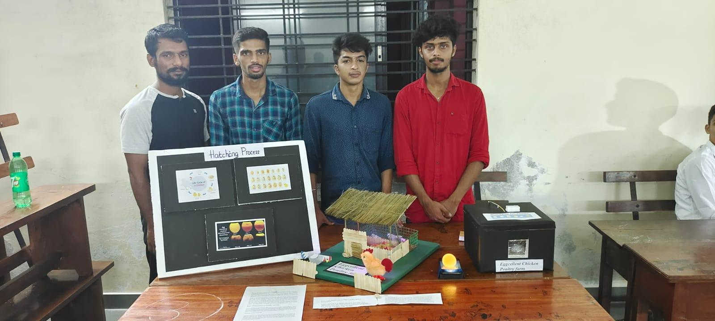
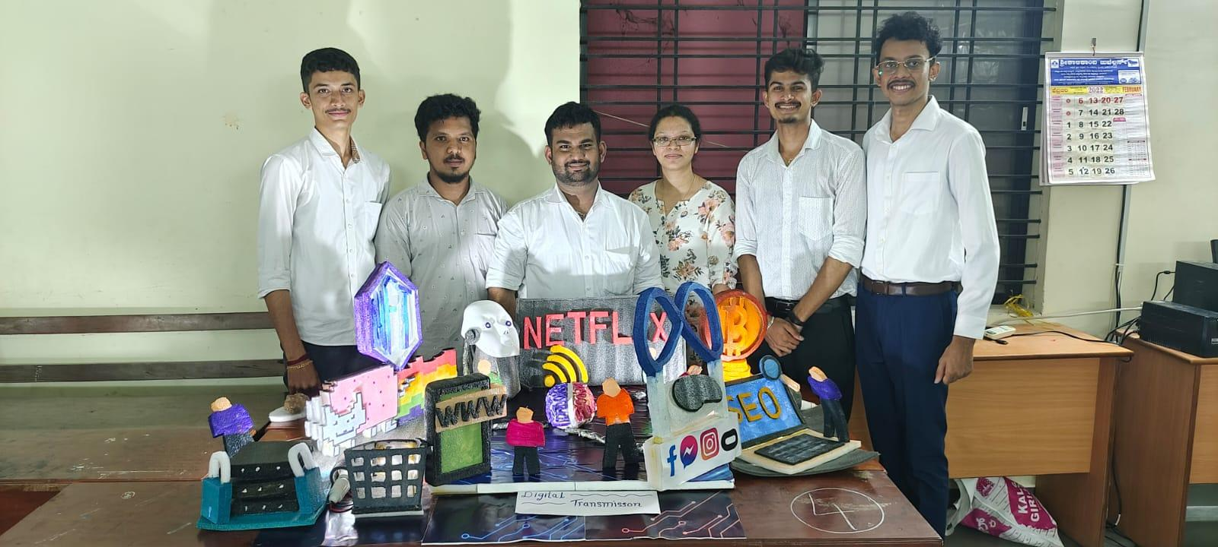

4.Cooking without fire competition was organized for Mcom students on 28 February 2022.

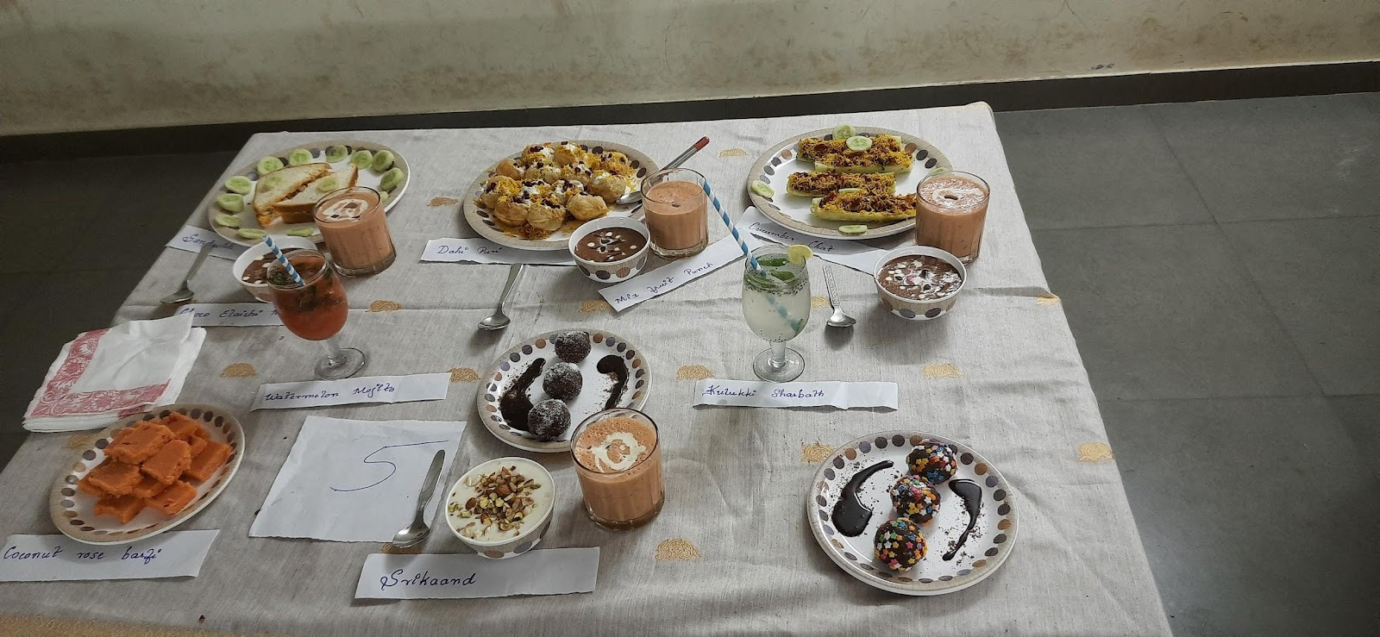

5.A workshop on “ Recents trends in Commerce & Management ” was organized from 5th March to 29th March , 2022. Workshop included session on
Preparation for KSET and NET Examination By Prof. Nagaraj Acharya , Interplay Between Taxation and Accounting By CA Gautham Kini K , Forensic Accounting & Other Related Concepts By CA Sonith Shetty , Importance of Public Speaking in a Corporate World By CA Vignesh Bhat , Financial Planning, Saving & Investing by C.A Pavan Sudhakar Shetty.

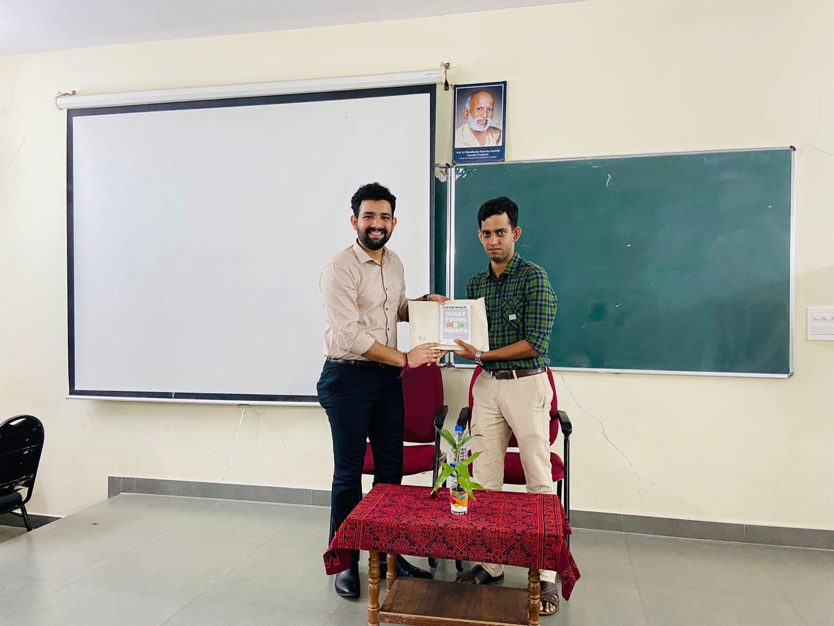

6.An outreach program was conducted on 3 June 2022. Students of II Mcom visited Udupi Town Police station . The police officers educated our students regarding formalities followed while filing complaints, how the tracking is done and other related matters. This program helped students to understand the working of the police department.

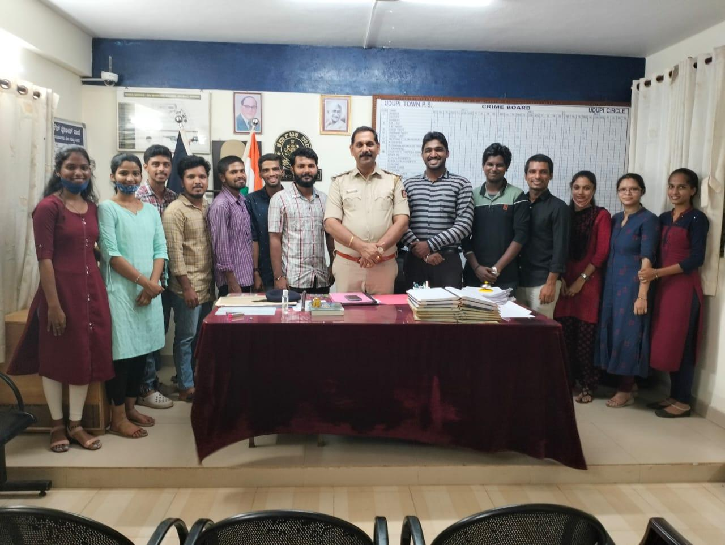

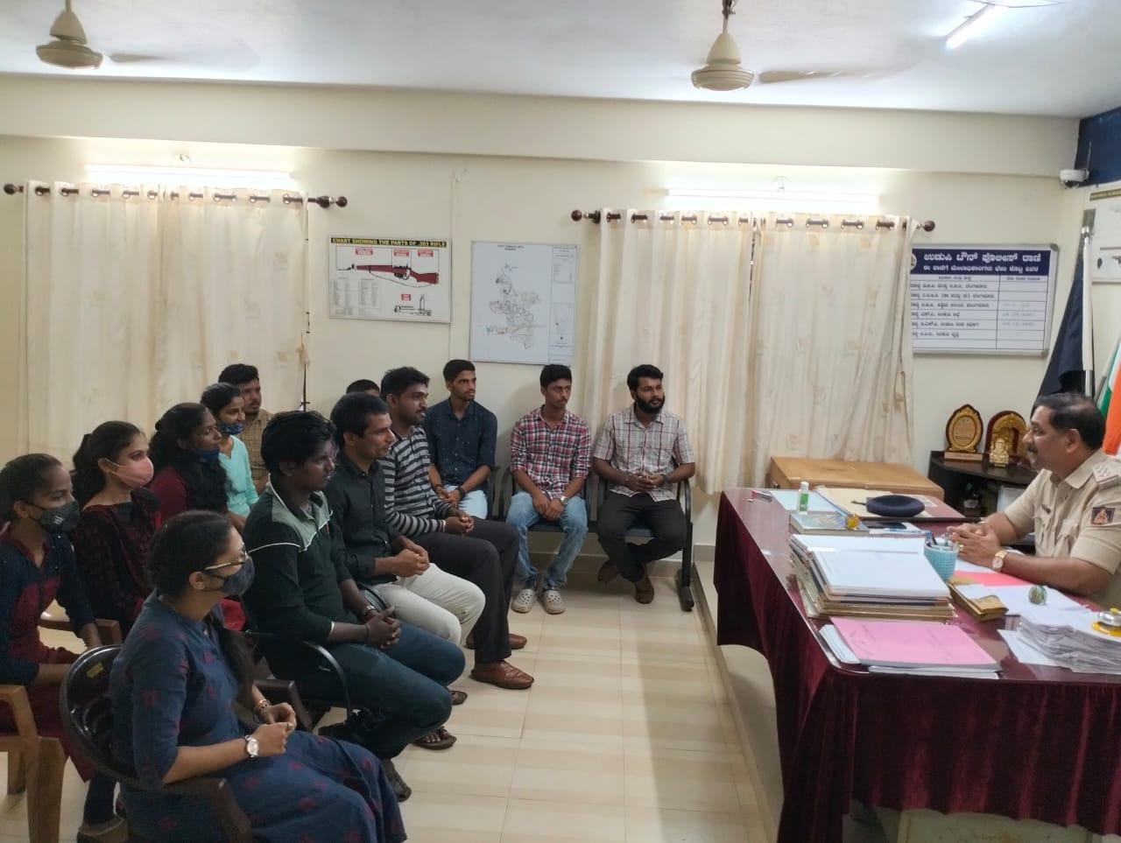

7.World Environment Day was celebrated on 6 June 2022.

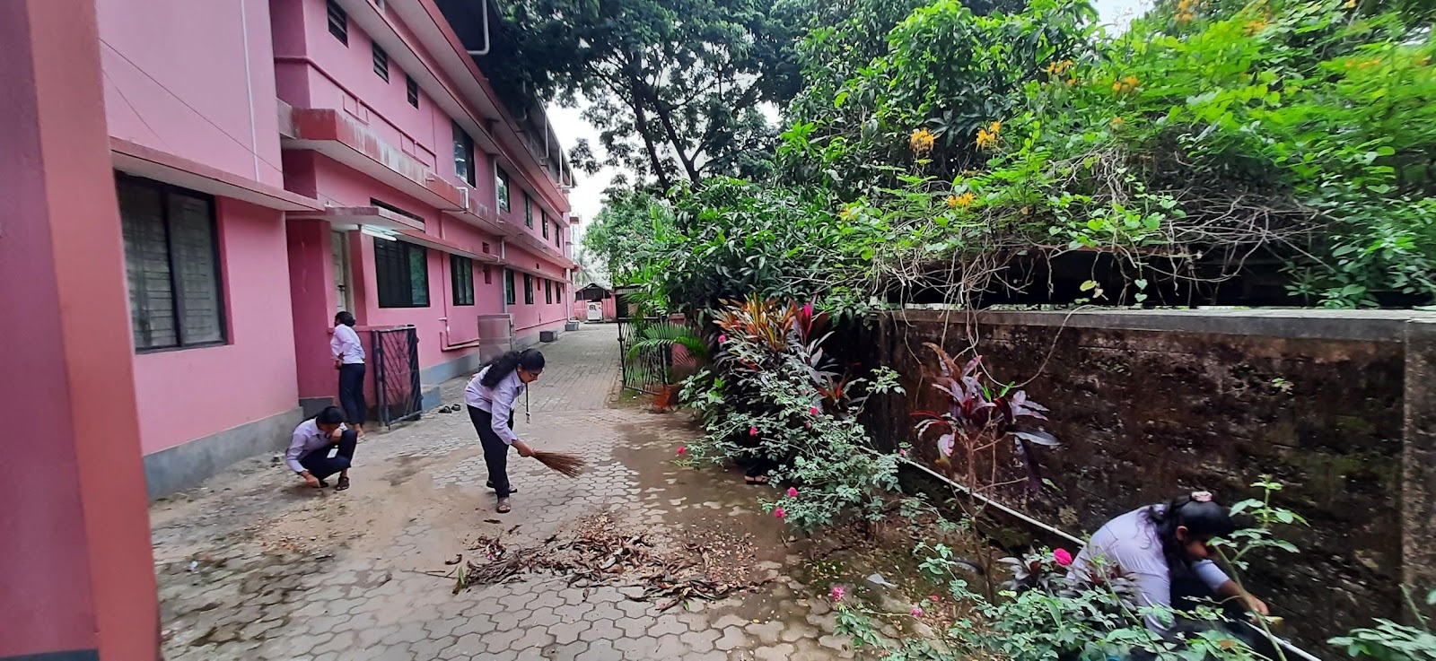

8.On July 5, 2022, II Mcom students were taken on an industrial visit to Amul Cattle Feeds and Dakshina Kannada Milk Producers Union in Mangalore

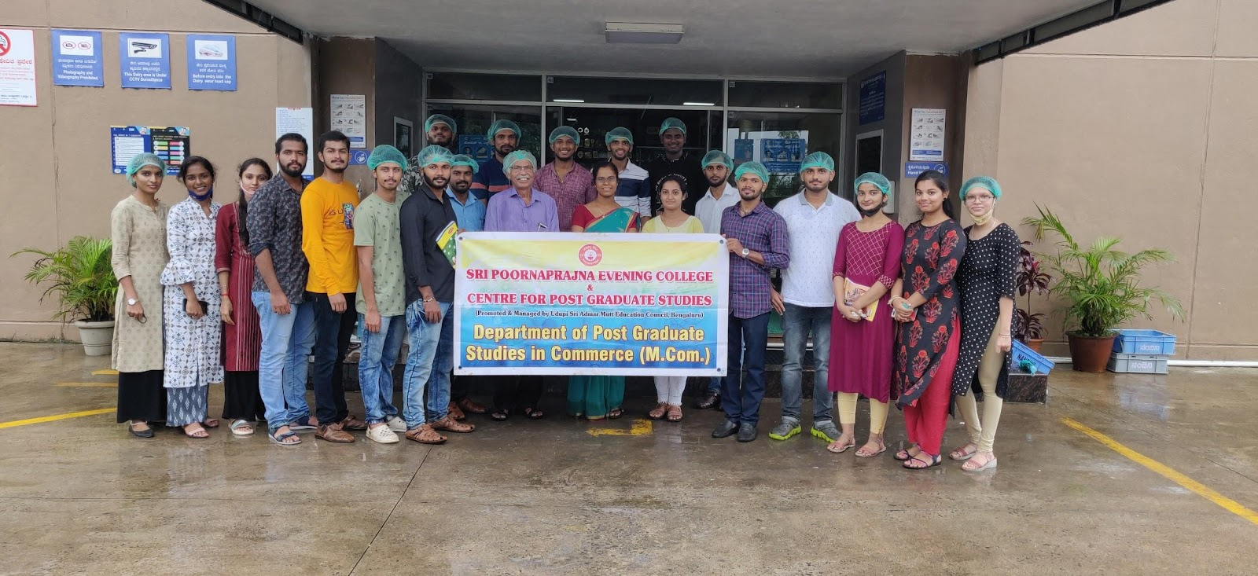

9.A special lecture on Research and Academic writing was organised on 25th July 2022. Dr. Umesh Maiya , Associate Professor, Dr. G Shankar Government First Grade College and PG Studies centre, Ajjarkad Udupi was the resource person.

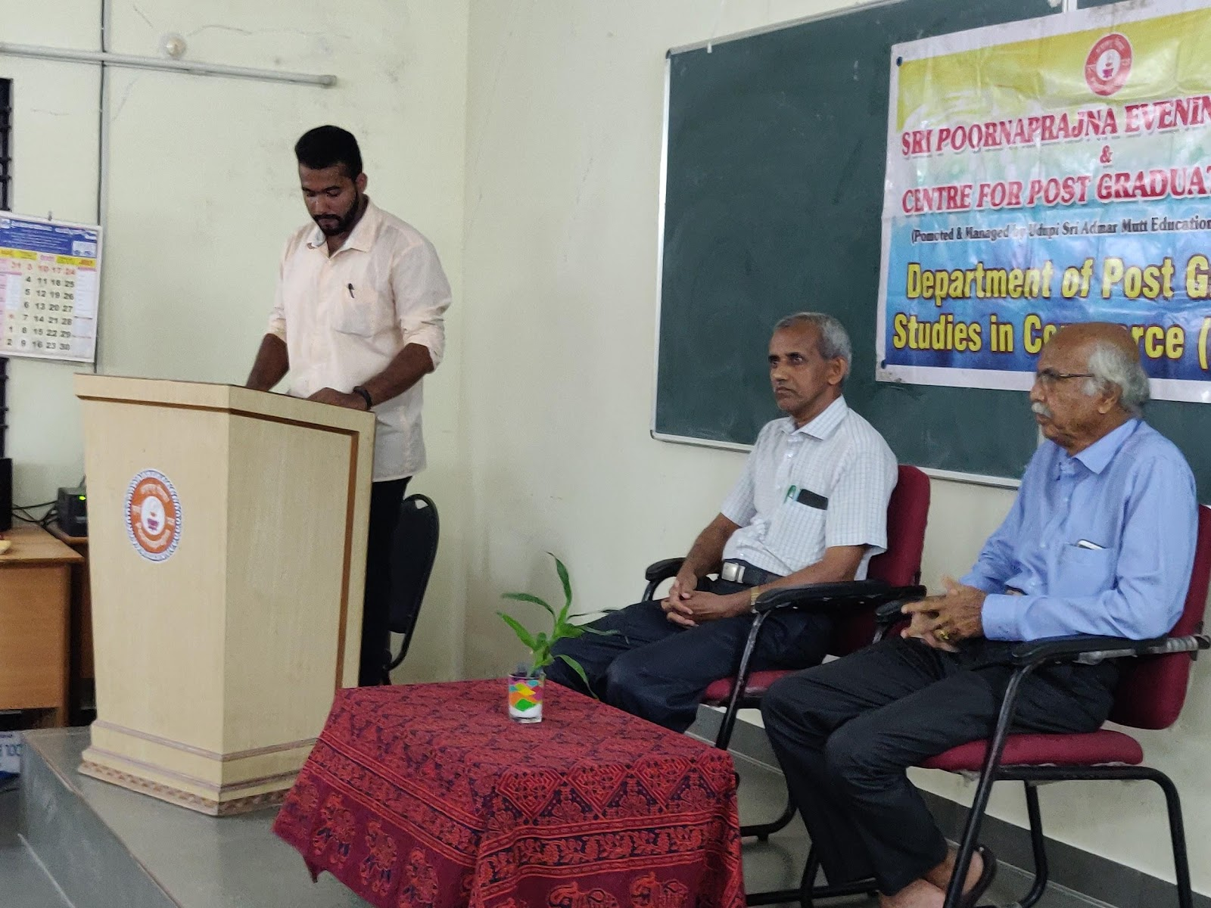
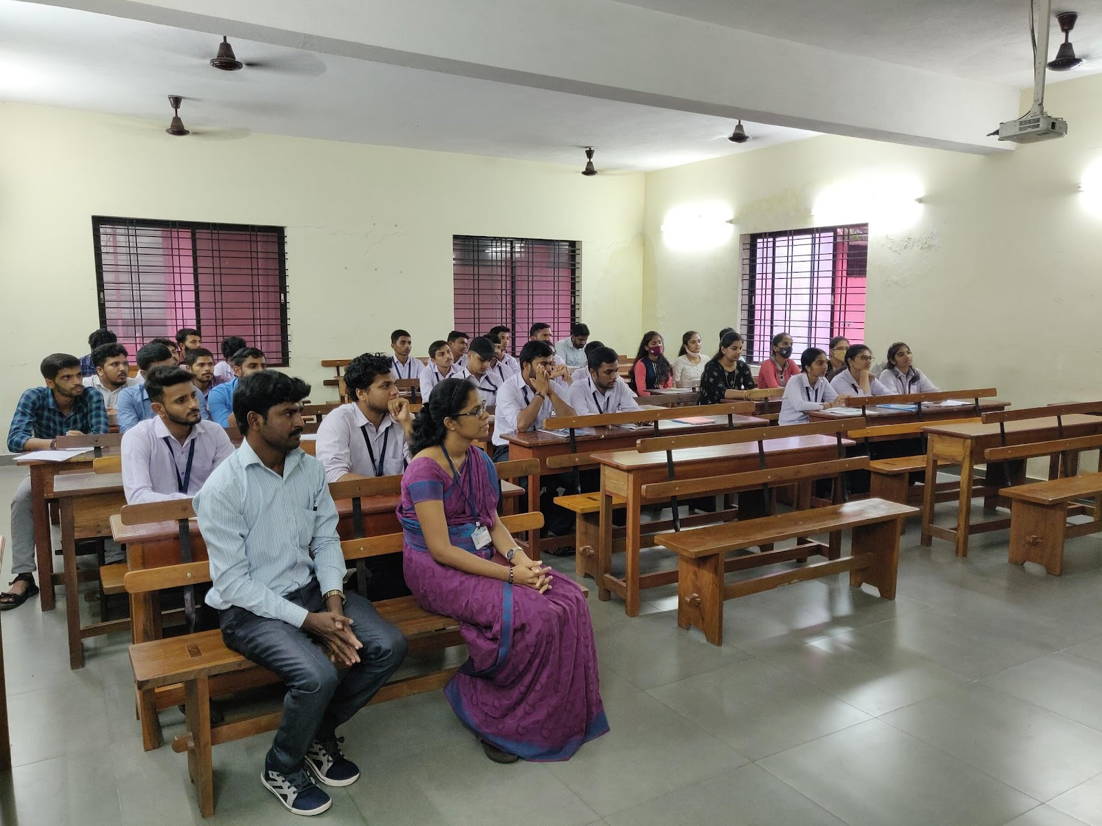

10.Kargil Vijay Diwas was observed by the PG Department of commerce on 26th July 2022.

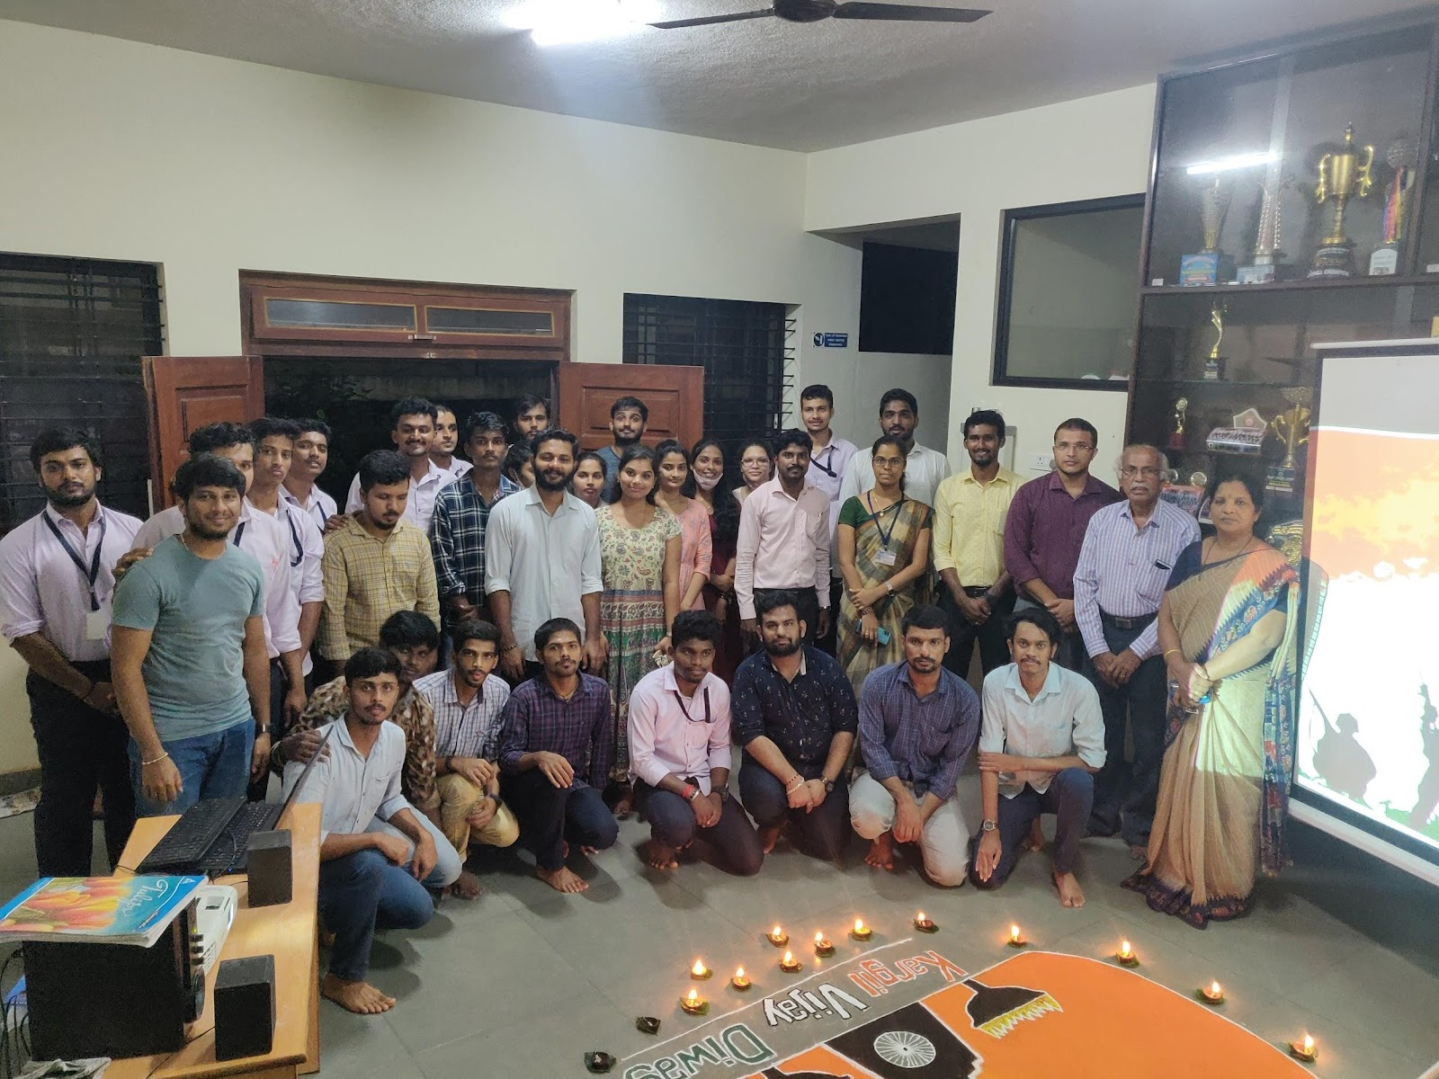

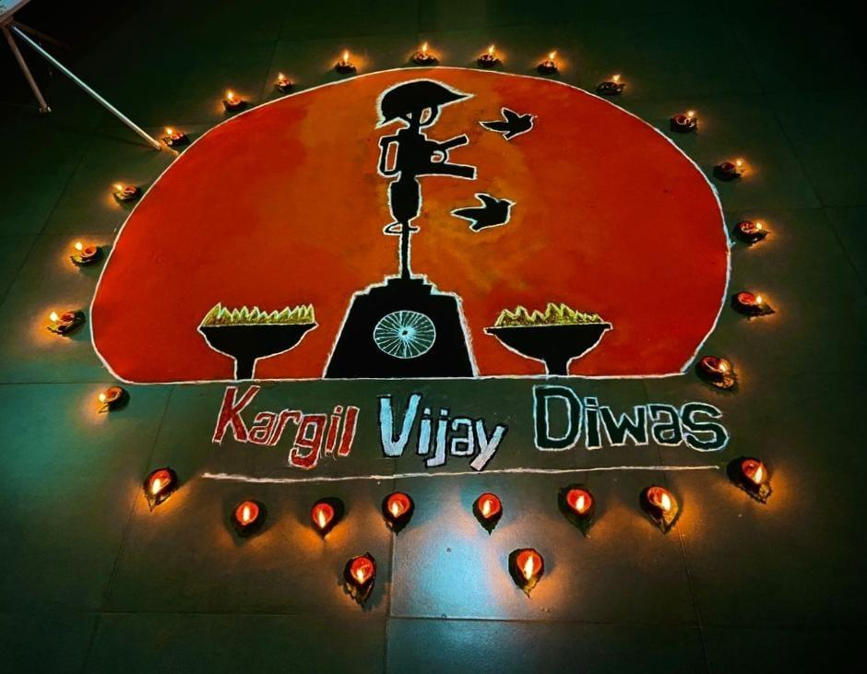

11.On 9 September 2022 , A session on “ Strategic Business Analysis of Market Leaders” was organized. Mr. Sujith Kumar ,our Alumni , presently , Articled Student at Dev Anand & Co, Chartered Accountants, Udupi was the resource person for the session.

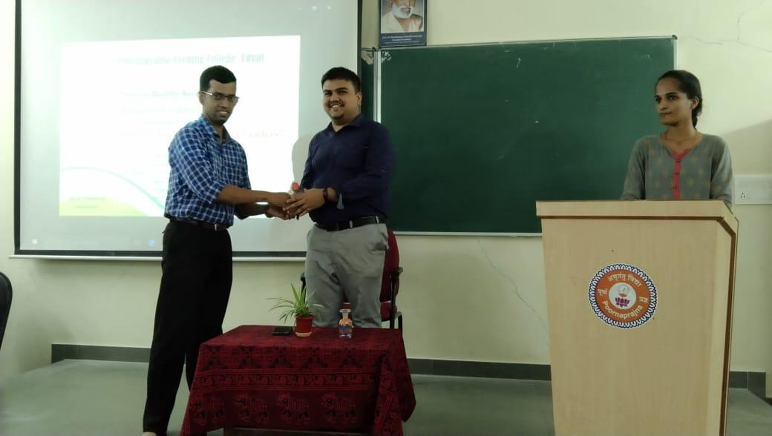

12.On 14 September 2022 , A session on “ Management Lessons in Mahabharata ” was organized. Mr. Shashank Ramesh Utpat , our Alumni , presently , Lecturer at Poornaprajna Pre University College , Udupi was the resource person for the session.

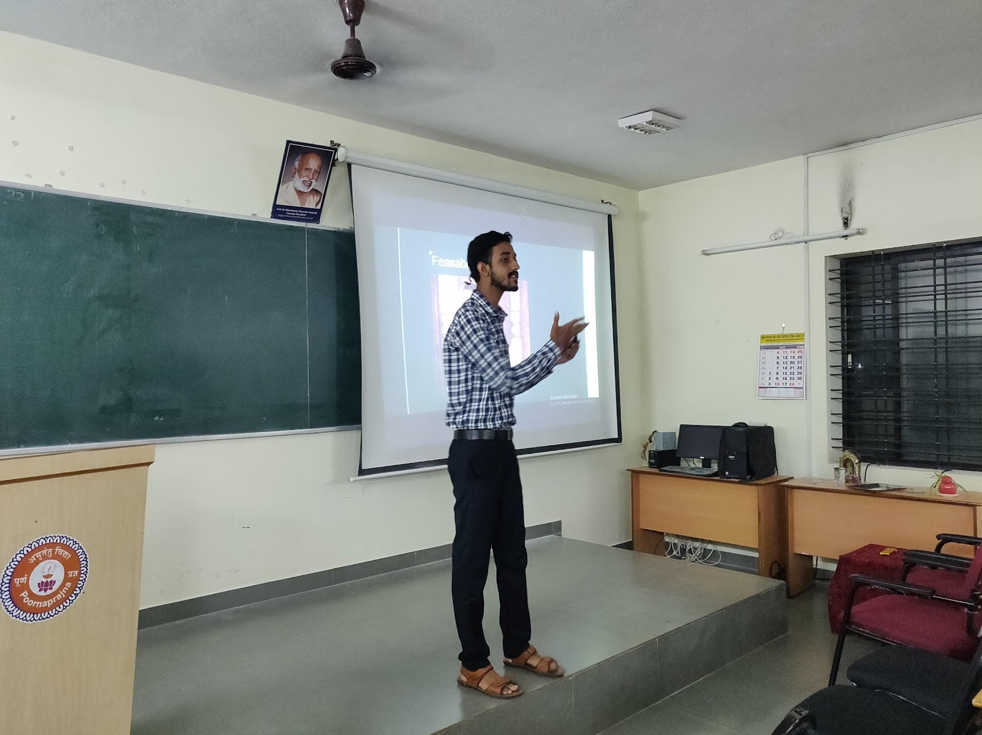

13.A Workshop on NET / KSET preparations.
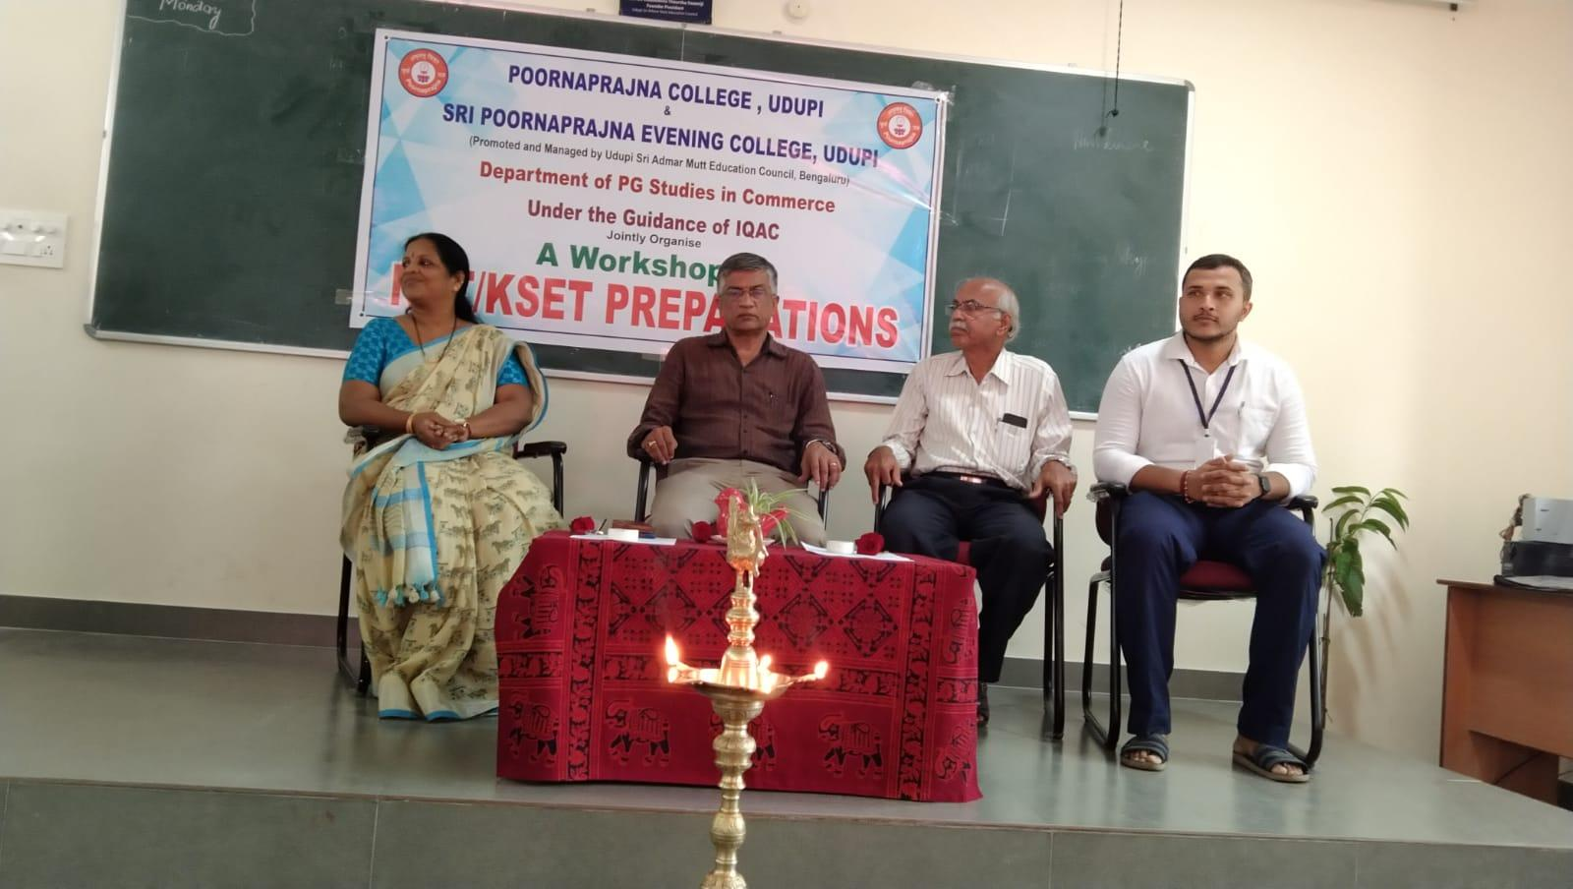
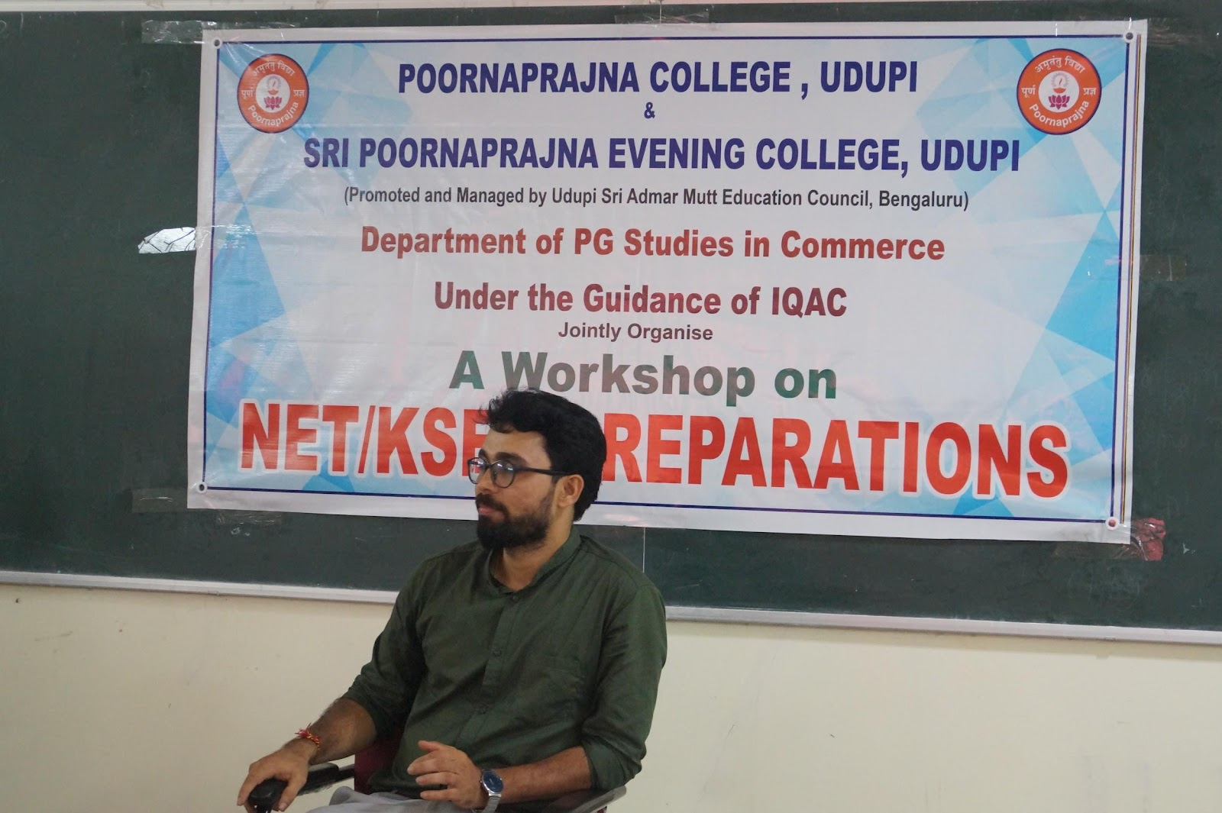

Activity Report 2022-23:

1.Inauguration of PG Programme
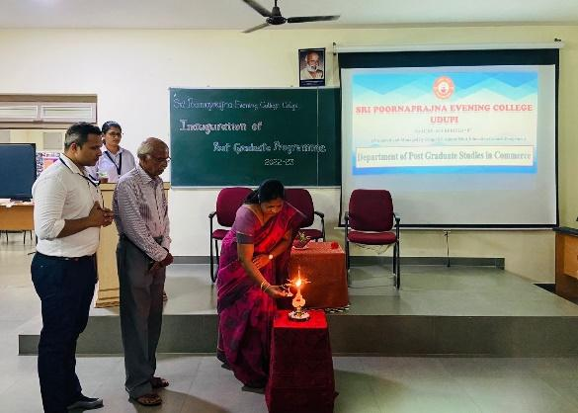
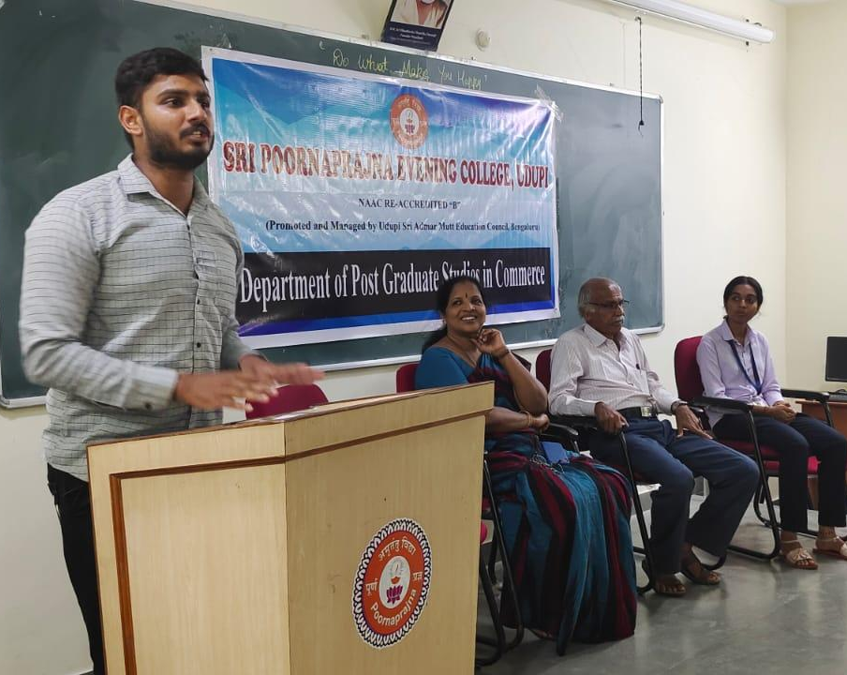
2.Splash

3.Power

4. Inauguration of Certificate Course on soft skill
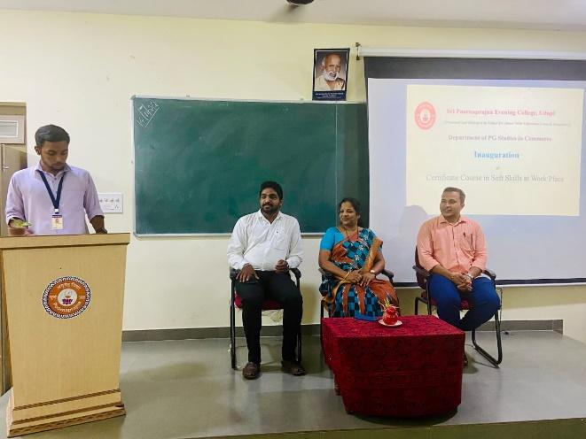

5.Deepavali Celebration

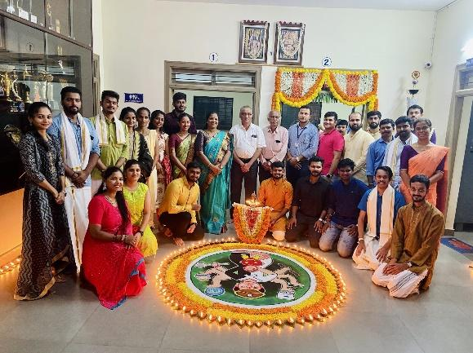

6.Industrial visit
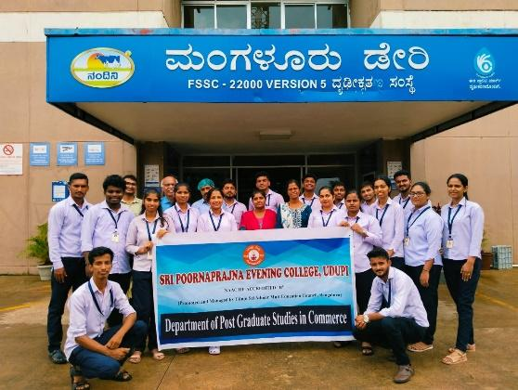

7. Panel Budget Discussion
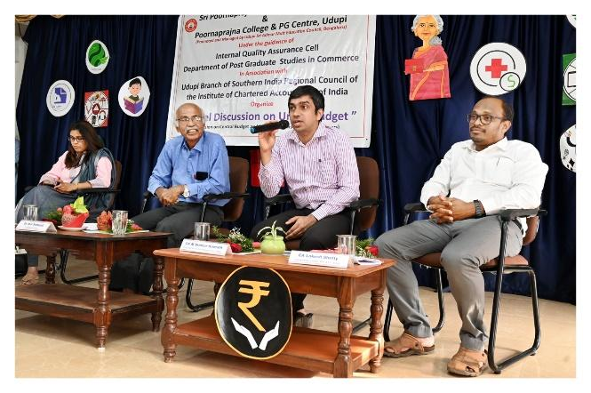

8.Session on Capital Market
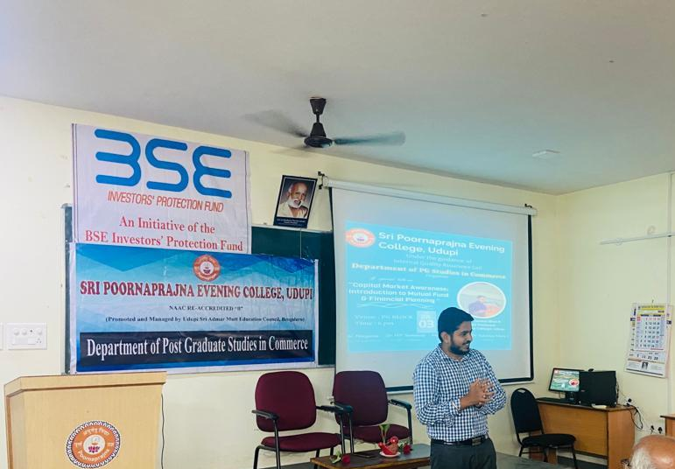

9.Brand Rangoli

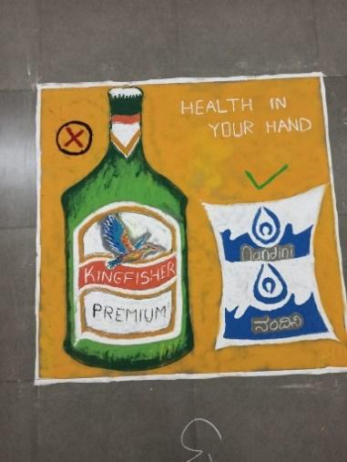

10. Orientation on swayam online course
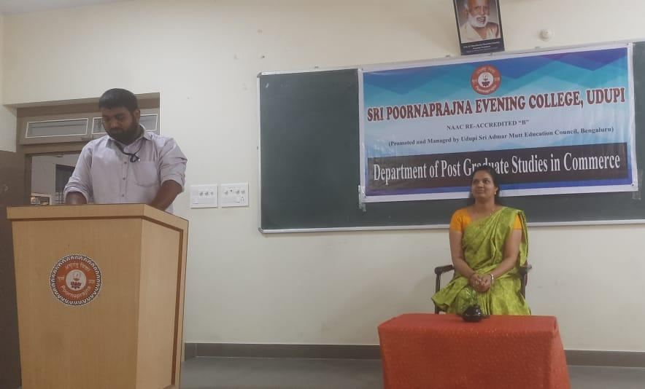
11. Be and make model - Swami Vivekananda
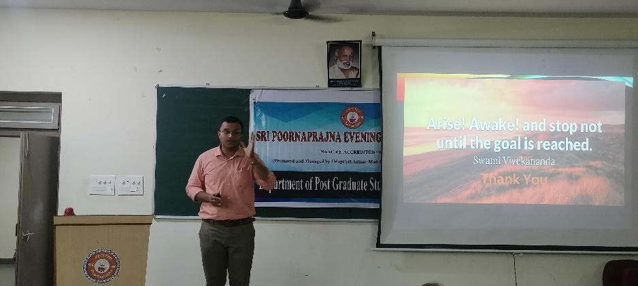

12.Kargil Vijay Diwas
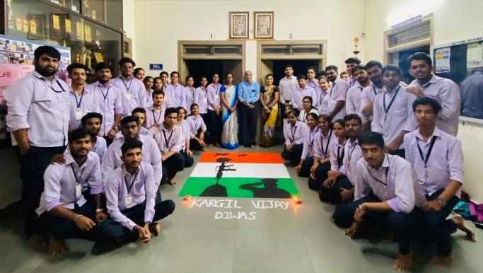

13. Commerce Model Making Competition
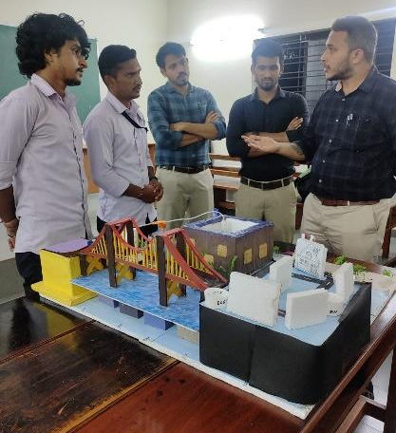
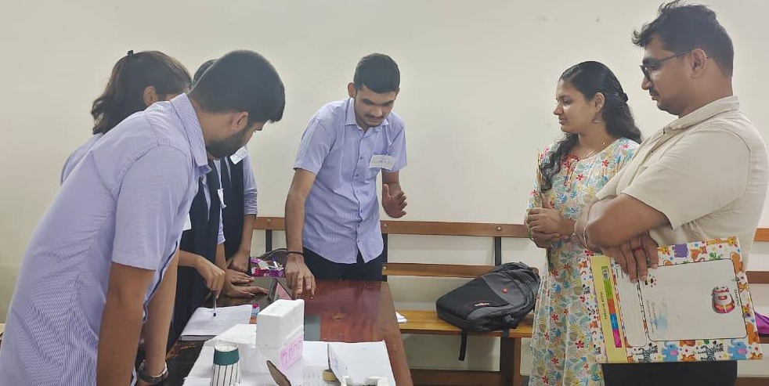
14. Cooking Without Fire
